**PAPER – II         PRACTICAL NO. : 04**

**AIM :  1. IMPLEMENT GRE TUNNEL**

**2. IMPLEMENT VTP**

**3. IMPLEMENT NAT**

**ROLL NO. : 02                                BATCH : M.SC PART-I**

**DATE : 05/11/22**

**GRE:**

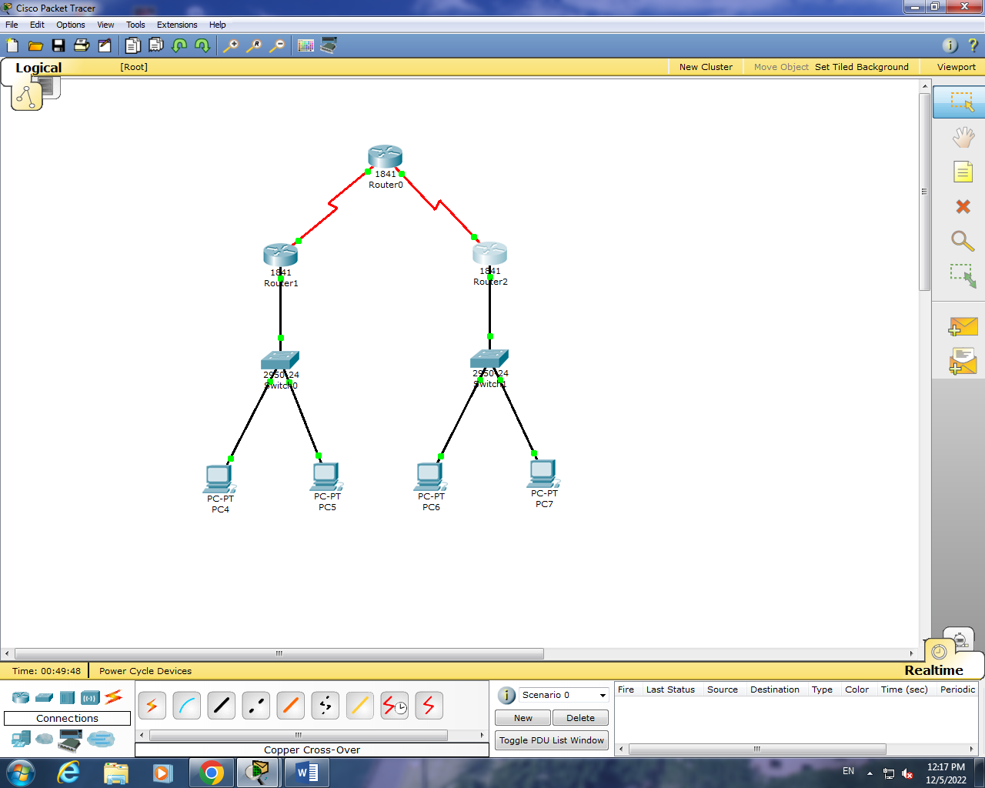

**Router 1 :**

Router#show ip int br

Interface IP-Address OK? Method Status Protocol

FastEthernet0/0 192.168.1.1 YES manual up up

FastEthernet0/1 unassigned YES unset administratively down down

Serial0/0/0 10.0.0.1 YES manual up up

Serial0/0/1 unassigned YES unset administratively down down

Vlan1 unassigned YES unset administratively down down

Router#en

Router#conf t

Enter configuration commands, one per line. End with CNTL/Z.

Router(config)#int tunnel 1

%LINK-5-CHANGED: Interface Tunnel1, changed state to up

Router(config-if)#ip address 50.50.50.1 255.255.255.0

Router(config-if)#tunnel source f0/0

Router(config-if)#exit

Router(config)#int tunnel 1

Router(config-if)#tunnel destination 20.0.0.2

%LINEPROTO-5-UPDOWN: Line protocol on Interface Tunnel1, changed state to up

Router(config-if)#end

Router#

%SYS-5-CONFIG_I: Configured from console by console

Router#show ip int br

Interface IP-Address OK? Method Status Protocol

FastEthernet0/0 192.168.1.1 YES manual up up

FastEthernet0/1 unassigned YES unset administratively down down

Serial0/0/0 10.0.0.1 YES manual up up

Serial0/0/1 unassigned YES unset administratively down down

Tunnel1 50.50.50.1 YES manual up up

Vlan1 unassigned YES unset administratively down down

Router#

**Router 2 :**

Router#show ip int br

Interface IP-Address OK? Method Status Protocol

FastEthernet0/0 171.15.10.1 YES manual up up

FastEthernet0/1 unassigned YES unset administratively down down

Serial0/0/0 unassigned YES unset administratively down down

Serial0/0/1 20.0.0.2 YES manual up up

Vlan1 unassigned YES unset administratively down down

Router#en

Router#conf t

Enter configuration commands, one per line. End with CNTL/Z.

Router(config)#int tunnel 1

%LINK-5-CHANGED: Interface Tunnel1, changed state to up

Router(config-if)#tunnel source f0/0

Router(config-if)#exit

Router(config)#int tunnel 1

Router(config-if)#tunnel destination 10.0.0.1

%LINEPROTO-5-UPDOWN: Line protocol on Interface Tunnel1, changed state to up

Router(config-if)#end

Router#

%SYS-5-CONFIG_I: Configured from console by console

Router#show ip int br

Interface IP-Address OK? Method Status Protocol

FastEthernet0/0 171.15.10.1 YES manual up up

FastEthernet0/1 unassigned YES unset administratively down down

Serial0/0/0 unassigned YES unset administratively down down

Serial0/0/1 20.0.0.2 YES manual up up

Tunnel1 50.50.50.2 YES manual up up

Vlan1 unassigned YES unset administratively down down

Router#

**VTP:**

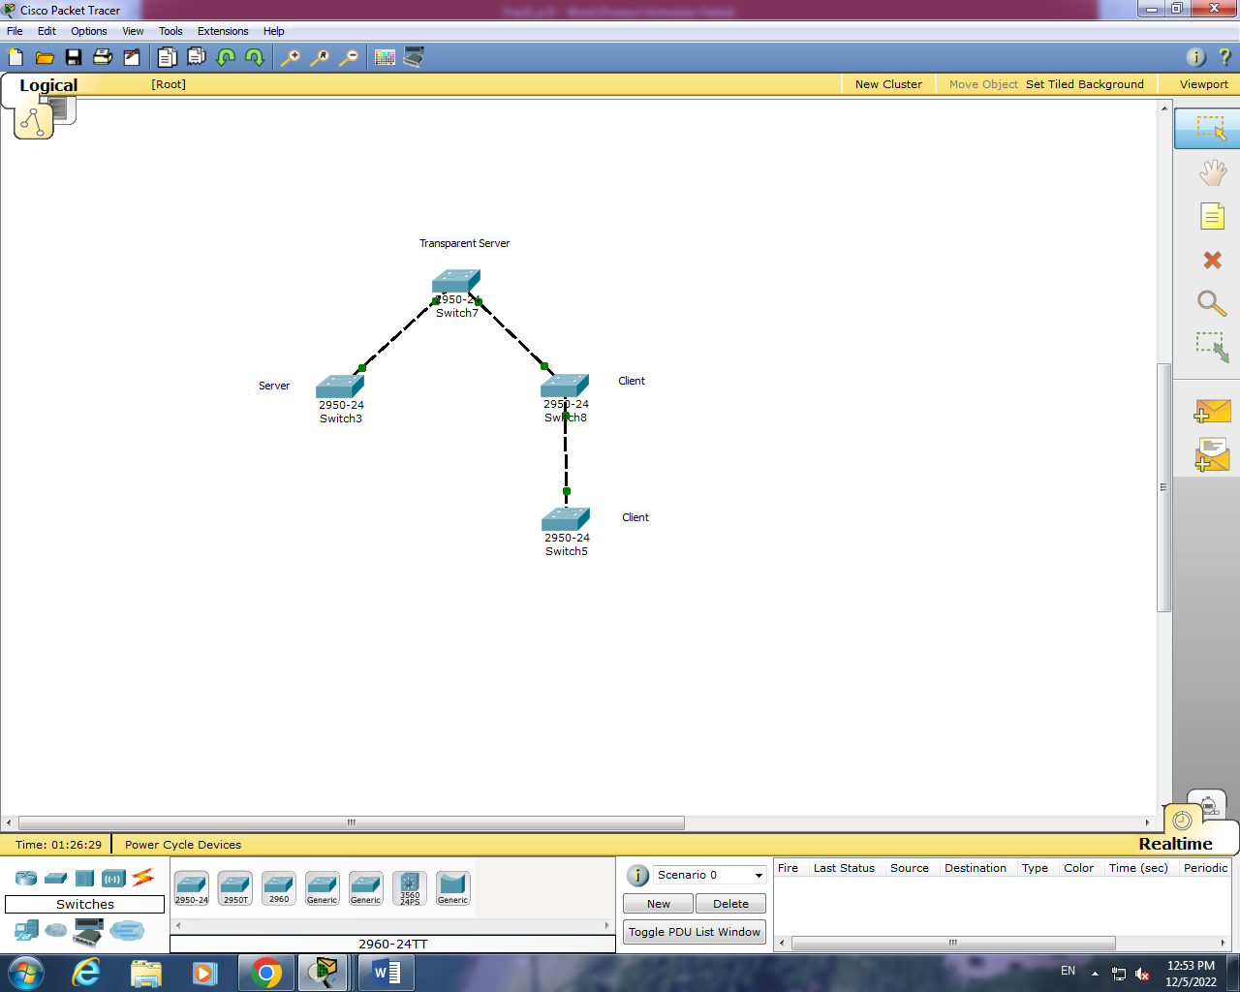

**Server :**

Switch>en

Switch#conf t

Enter configuration commands, one per line. End with CNTL/Z.

Switch(config)#int f0/1

Switch(config-if)#switchport mode trunk

%LINEPROTO-5-UPDOWN: Line protocol on Interface FastEthernet0/1, changed state to down

%LINEPROTO-5-UPDOWN: Line protocol on Interface FastEthernet0/1, changed state to up

Switch(config-if)#end

Switch#

%SYS-5-CONFIG_I: Configured from console by console

Switch#show vtp status

VTP Version : 2

Configuration Revision : 0

Maximum VLANs supported locally : 255

Number of existing VLANs : 5

VTP Operating Mode : Server

VTP Domain Name :

VTP Pruning Mode : Disabled

VTP V2 Mode : Disabled

VTP Traps Generation : Disabled

MD5 digest : 0x7D 0x5A 0xA6 0x0E 0x9A 0x72 0xA0 0x3A

Configuration last modified by 0.0.0.0 at 0-0-00 00:00:00

Local updater ID is 0.0.0.0 (no valid interface found)

Switch#conf t

Enter configuration commands, one per line. End with CNTL/Z.

Switch(config)#int f0/1

Switch(config-if)#vtp mode server

Device mode already VTP SERVER.

Switch(config)#vtp domain VTPServer

Changing VTP domain name from NULL to VTPServer

Switch(config)#vlan 10

Switch(config-vlan)#Name GJC

Switch(config-vlan)#end

Switch#

%SYS-5-CONFIG_I: Configured from console by console

Switch#show vlan

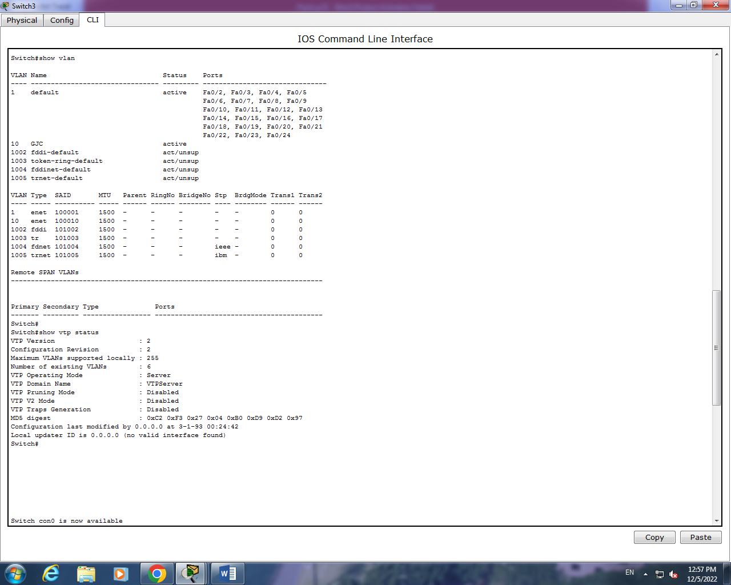

**Transparent Server :**

Switch>en

Switch#conf t

Enter configuration commands, one per line. End with CNTL/Z.

Switch(config)#int f0/1

Switch(config-if)#switchport mode trunk

%LINEPROTO-5-UPDOWN: Line protocol on Interface FastEthernet0/1, changed state to down

%LINEPROTO-5-UPDOWN: Line protocol on Interface FastEthernet0/1, changed state to up

Switch(config-if)#end

Switch#

%SYS-5-CONFIG_I: Configured from console by console

Switch#show vtp status

VTP Version : 2

Configuration Revision : 0

Maximum VLANs supported locally : 255

Number of existing VLANs : 5

VTP Operating Mode : Server

VTP Domain Name :

VTP Pruning Mode : Disabled

VTP V2 Mode : Disabled

VTP Traps Generation : Disabled

MD5 digest : 0x7D 0x5A 0xA6 0x0E 0x9A 0x72 0xA0 0x3A

Configuration last modified by 0.0.0.0 at 0-0-00 00:00:00

Local updater ID is 0.0.0.0 (no valid interface found)

Switch#conf t

Enter configuration commands, one per line. End with CNTL/Z.

Switch(config)#int f0/1

Switch(config-if)#vtp mode transparent

Device mode already VTP TRANSPARENT.

Switch(config)#vtp domain VTPTransparent

Changing VTP domain name from NULL to VTPTransparent

Switch(config)#vlan 10

Switch(config-vlan)#Name University

Switch(config-vlan)#end

Switch#

%SYS-5-CONFIG_I: Configured from console by console

Switch#show vlan

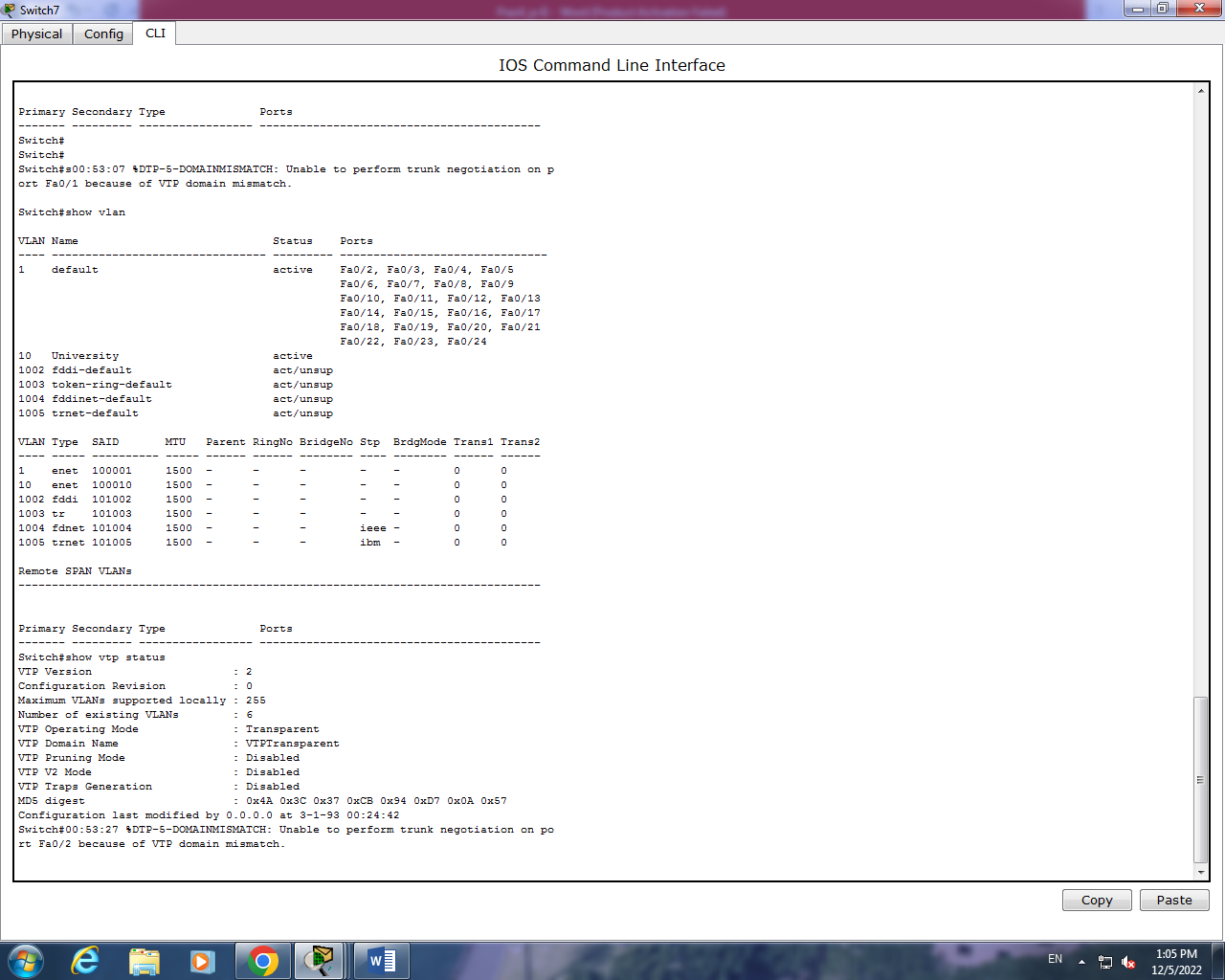

**Client :**

Switch>en

Switch#conf t

Enter configuration commands, one per line. End with CNTL/Z.

Switch(config)#int f0/1

Switch(config-if)#switchport mode trunk

%LINEPROTO-5-UPDOWN: Line protocol on Interface FastEthernet0/1, changed state to down

%LINEPROTO-5-UPDOWN: Line protocol on Interface FastEthernet0/1, changed state to up

Switch(config-if)#end

Switch#

%SYS-5-CONFIG_I: Configured from console by console

Switch#show vtp status

VTP Version : 2

Configuration Revision : 0

Maximum VLANs supported locally : 255

Number of existing VLANs : 5

VTP Operating Mode : Server

VTP Domain Name : VTPClient

VTP Pruning Mode : Disabled

VTP V2 Mode : Disabled

VTP Traps Generation : Disabled

MD5 digest : 0xC0 0x46 0xBB 0x26 0x20 0x8B 0xB1 0x44

Configuration last modified by 0.0.0.0 at 0-0-00 00:00:00

Local updater ID is 0.0.0.0 (no valid interface found)

Switch#conf t

Enter configuration commands, one per line. End with CNTL/Z.

Switch(config)#int f0/1

Switch(config-if)#vtp mode client

Setting device to VTP CLIENT mode.

Switch(config)#vtp domain VTPClient

Domain name already set to VTPClient.

Switch(config)#end

%SYS-5-CONFIG_I: Configured from console by console

Switch#show vtp status

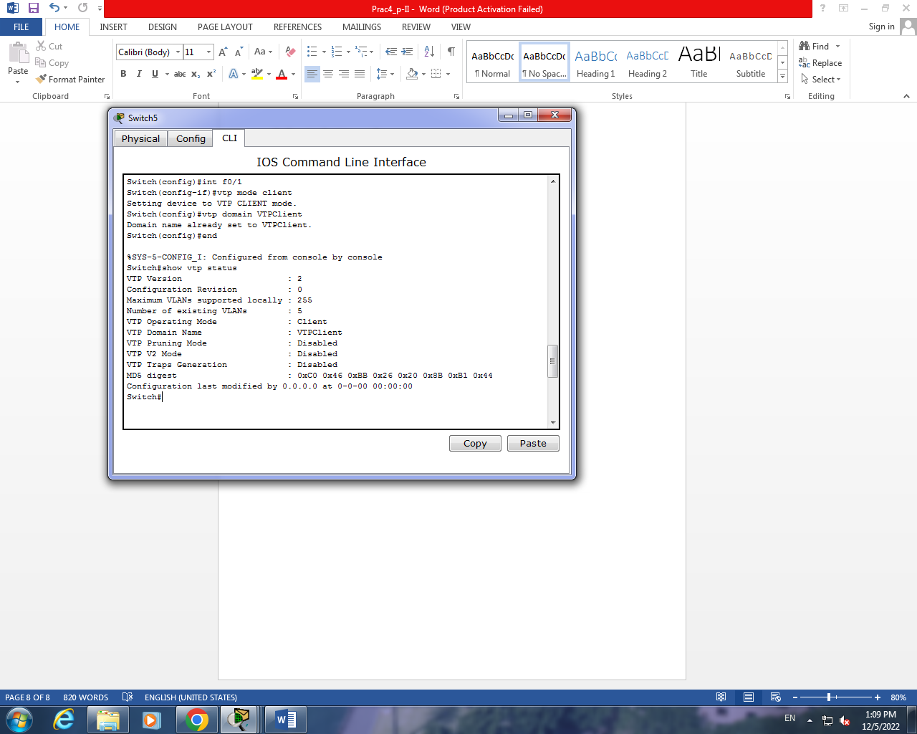

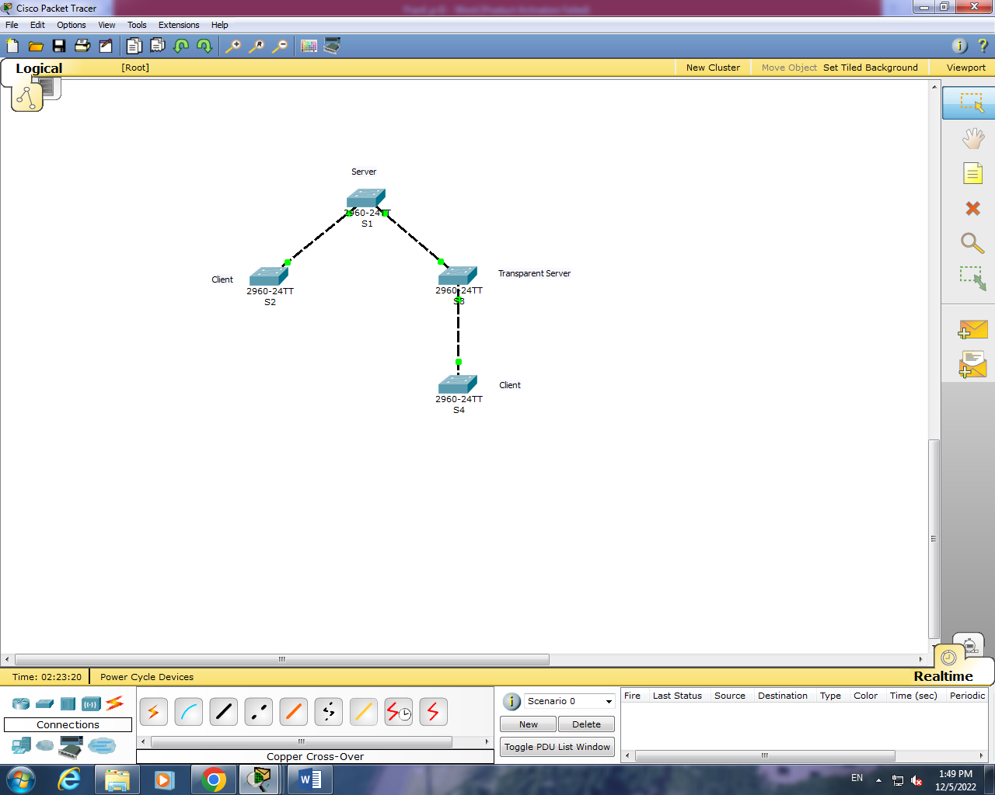

**S1 :**

Switch#en

Switch#conf t

Enter configuration commands, one per line. End with CNTL/Z.

Switch(config)#int f0/1

Switch(config-if)#switchport mode trunk

%LINEPROTO-5-UPDOWN: Line protocol on Interface FastEthernet0/1, changed state to down

%LINEPROTO-5-UPDOWN: Line protocol on Interface FastEthernet0/1, changed state to up

Switch(config-if)#exit

Switch(config)#int f0/2

Switch(config-if)#switchport mode trunk

%LINEPROTO-5-UPDOWN: Line protocol on Interface FastEthernet0/2, changed state to down

%LINEPROTO-5-UPDOWN: Line protocol on Interface FastEthernet0/2, changed state to up

Switch(config-if)#exit

Switch(config)#end

%SYS-5-CONFIG_I: Configured from console by console

Switch#show vtp status

VTP Version : 2

Configuration Revision : 0

Maximum VLANs supported locally : 255

Number of existing VLANs : 5

VTP Operating Mode : Server

VTP Domain Name :

VTP Pruning Mode : Disabled

VTP V2 Mode : Disabled

VTP Traps Generation : Disabled

MD5 digest : 0x7D 0x5A 0xA6 0x0E 0x9A 0x72 0xA0 0x3A

Configuration last modified by 0.0.0.0 at 0-0-00 00:00:00

Local updater ID is 0.0.0.0 (no valid interface found)

Switch#conf t

Enter configuration commands, one per line. End with CNTL/Z.

Switch(config)#int f0/1

Switch(config-if)#vtp mode server

Device mode already VTP SERVER.

Switch(config)#vtp domain VTPServer

Changing VTP domain name from NULL to VTPServer

Switch(config)#end

%SYS-5-CONFIG_I: Configured from console by console

Switch#show vtp status

VTP Version : 2

Configuration Revision : 0

Maximum VLANs supported locally : 255

Number of existing VLANs : 5

VTP Operating Mode : Server

VTP Domain Name : VTPServer

VTP Pruning Mode : Disabled

VTP V2 Mode : Disabled

VTP Traps Generation : Disabled

MD5 digest : 0xB8 0x02 0x0F 0x8B 0xD8 0xFA 0x0B 0x13

Configuration last modified by 0.0.0.0 at 0-0-00 00:00:00

Local updater ID is 0.0.0.0 (no valid interface found)

Switch#conf t

Enter configuration commands, one per line. End with CNTL/Z.

Switch(config)#int f0/1

Switch(config-if)#vlan 10

Switch(config-vlan)#Name GJC

Switch(config-vlan)#end

Switch#

%SYS-5-CONFIG_I: Configured from console by console

Switch#show vtp status

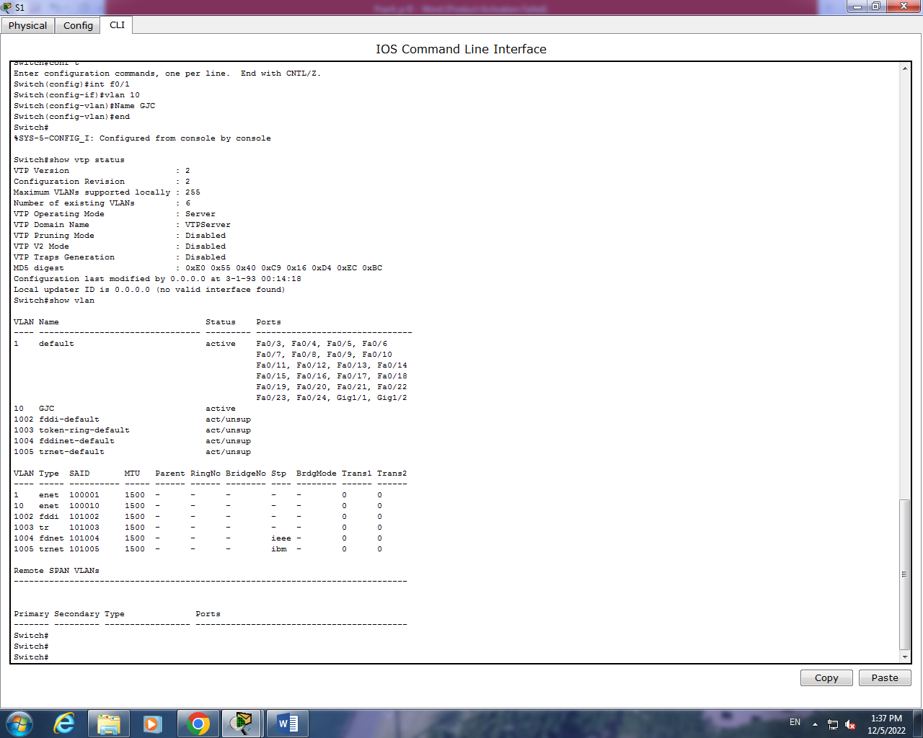

**S2 :**

Switch>en

Switch#conf t

Enter configuration commands, one per line. End with CNTL/Z.

Switch(config)#int f0/1

Switch(config-if)#switchport mode trunk

Switch(config-if)#end

%SYS-5-CONFIG_I: Configured from console by console

Switch#show vtp status

VTP Version : 2

Configuration Revision : 2

Maximum VLANs supported locally : 255

Number of existing VLANs : 6

VTP Operating Mode : Server

VTP Domain Name : VTPServer

VTP Pruning Mode : Disabled

VTP V2 Mode : Disabled

VTP Traps Generation : Disabled

MD5 digest : 0xE0 0x55 0x40 0xC9 0x16 0xD4 0xEC 0xBC

Configuration last modified by 0.0.0.0 at 3-1-93 00:14:18

Local updater ID is 0.0.0.0 (no valid interface found)

Switch#conf t

Enter configuration commands, one per line. End with CNTL/Z.

Switch(config)#int f0/1

Switch(config-if)#vtp mode client

Setting device to VTP CLIENT mode.

Switch(config)#vtp domain VTPClient

Changing VTP domain name from VTPServer to VTPClient

Switch(config)#exit

%SYS-5-CONFIG_I: Configured from console by console

Switch#show vtp status

VTP Version : 2

Configuration Revision : 0

Maximum VLANs supported locally : 255

Number of existing VLANs : 6

VTP Operating Mode : Client

VTP Domain Name : VTPClient

VTP Pruning Mode : Disabled

VTP V2 Mode : Disabled

VTP Traps Generation : Disabled

MD5 digest : 0x1B 0x59 0xC6 0x3B 0xFF 0xEF 0x8A 0x18

Configuration last modified by 0.0.0.0 at 3-1-93 00:14:18

Switch#show vlan

VLAN Name Status Ports

---- -------------------------------- --------- -------------------------------

1 default active Fa0/2, Fa0/3, Fa0/4, Fa0/5

Fa0/6, Fa0/7, Fa0/8, Fa0/9

Fa0/10, Fa0/11, Fa0/12, Fa0/13

Fa0/14, Fa0/15, Fa0/16, Fa0/17

Fa0/18, Fa0/19, Fa0/20, Fa0/21

Fa0/22, Fa0/23, Fa0/24, Gig1/1

Gig1/2

10 GJC active

1002 fddi-default act/unsup

1003 token-ring-default act/unsup

1004 fddinet-default act/unsup

1005 trnet-default act/unsup

VLAN Type SAID MTU Parent RingNo BridgeNo Stp BrdgMode Trans1 Trans2

---- ----- ---------- ----- ------ ------ -------- ---- -------- ------ ------

1 enet 100001 1500 - - - - - 0 0

10 enet 100010 1500 - - - - - 0 0

1002 fddi 101002 1500 - - - - - 0 0

1003 tr 101003 1500 - - - - - 0 0

**S3 :**

Switch>en

Switch#conf t

Enter configuration commands, one per line. End with CNTL/Z.

Switch(config)#int f0/1

Switch(config-if)#switchport mode trunk

Switch(config-if)#exit

Switch(config)#end

Switch#

%SYS-5-CONFIG_I: Configured from console by console

show vtp status

VTP Version : 2

Configuration Revision : 2

Maximum VLANs supported locally : 255

Number of existing VLANs : 6

VTP Operating Mode : Server

VTP Domain Name : VTPServer

VTP Pruning Mode : Disabled

VTP V2 Mode : Disabled

VTP Traps Generation : Disabled

MD5 digest : 0xE0 0x55 0x40 0xC9 0x16 0xD4 0xEC 0xBC

Configuration last modified by 0.0.0.0 at 3-1-93 00:14:18

Local updater ID is 0.0.0.0 (no valid interface found)

Switch#conf t

Enter configuration commands, one per line. End with CNTL/Z.

Switch(config)#int f0/1

Switch(config-if)#vtp mode transparent

Setting device to VTP TRANSPARENT mode.

Switch(config)#vtp domain VTPTransparent

Changing VTP domain name from VTPServer to VTPTransparent

Switch(config)#end

%SYS-5-CONFIG_I: Configured from console by console

Switch#show vtp status

VTP Version : 2

Configuration Revision : 0

Maximum VLANs supported locally : 255

Number of existing VLANs : 6

VTP Operating Mode : Transparent

VTP Domain Name : VTPTransparent

VTP Pruning Mode : Disabled

VTP V2 Mode : Disabled

VTP Traps Generation : Disabled

MD5 digest : 0x96 0xCA 0x57 0x93 0x70 0xF4 0x83 0x36

Configuration last modified by 0.0.0.0 at 3-1-93 00:14:18

Switch#show vlan

VLAN Name Status Ports

---- -------------------------------- --------- -------------------------------

1 default active Fa0/2, Fa0/3, Fa0/4, Fa0/5

Fa0/6, Fa0/7, Fa0/8, Fa0/9

Fa0/10, Fa0/11, Fa0/12, Fa0/13

Fa0/14, Fa0/15, Fa0/16, Fa0/17

Fa0/18, Fa0/19, Fa0/20, Fa0/21

Fa0/22, Fa0/23, Fa0/24, Gig1/1

Gig1/2

10 GJC active

1002 fddi-default act/unsup

1003 token-ring-default act/unsup

1004 fddinet-default act/unsup

1005 trnet-default act/unsup

VLAN Type SAID MTU Parent RingNo BridgeNo Stp BrdgMode Trans1 Trans2

---- ----- ---------- ----- ------ ------ -------- ---- -------- ------ ------

1 enet 100001 1500 - - - - - 0 0

10 enet 100010 1500 - - - - - 0 0

1002 fddi 101002 1500 - - - - - 0 0

1003 tr 101003 1500 - - - - - 0 0